Project Analysis

**Title**: TeamTrackr

**Description**: With the TeamTrackr app we want to make it easy for a sports teams to register training schedules and games. We want players to be able to let know their presence. We want coaches to register and edit the team agenda. For each season we show a total attendance for each individual player.

# User Stories

**User Story 1**

As a coach

I’m able to register a training

So that I can manage and organize my team’s agenda

**WireFrame:**

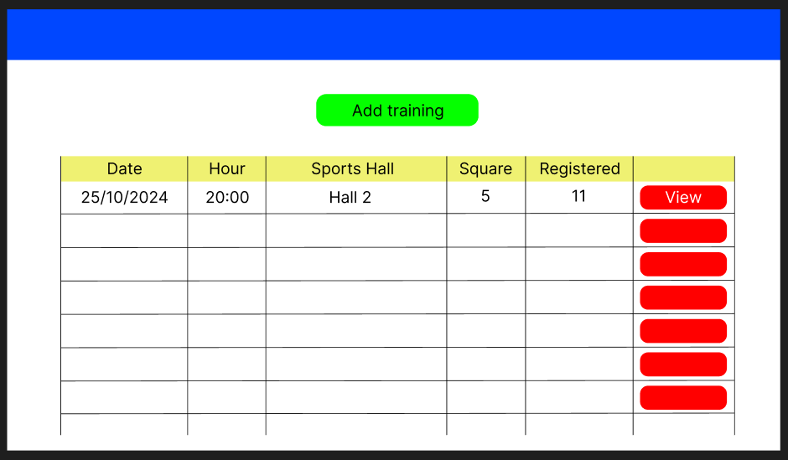

**Acceptance criteria:**

* If a coach clicks on a button “add training”, you can add the details of the training, a description, the date, the time and location.
* The training can not be in the past
* The location, time and date cannot be null
* Only a coach can register a training

**User story 2**

As a coach

I’m able to register a game

So that I can manage and organize my team’s agenda

**WireFrame:**

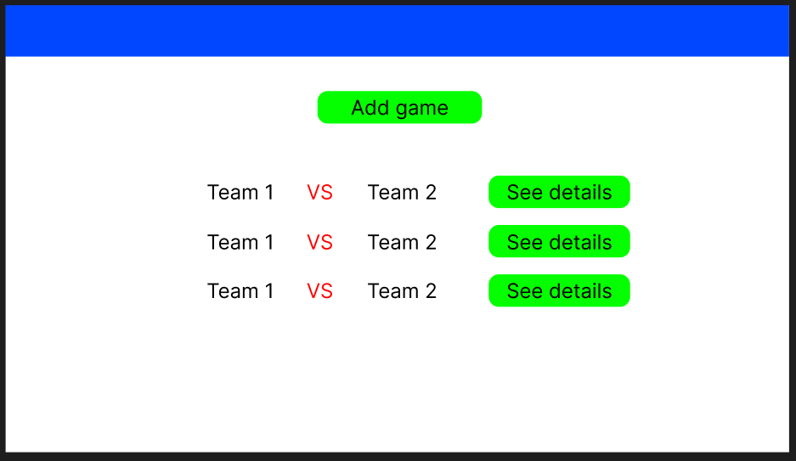

**Acceptance criteria:**

* If you click on a button add game, you can add the details of the game, a description, the date, the time and location.
* The training cannot be in the past
* The location, time and date cannot be null
* Only a coach can register a game

**User Story 3**

As a player

I’m able to register my presence on a training

So that I can keep my coach and teammates informed

**WireFrame:**

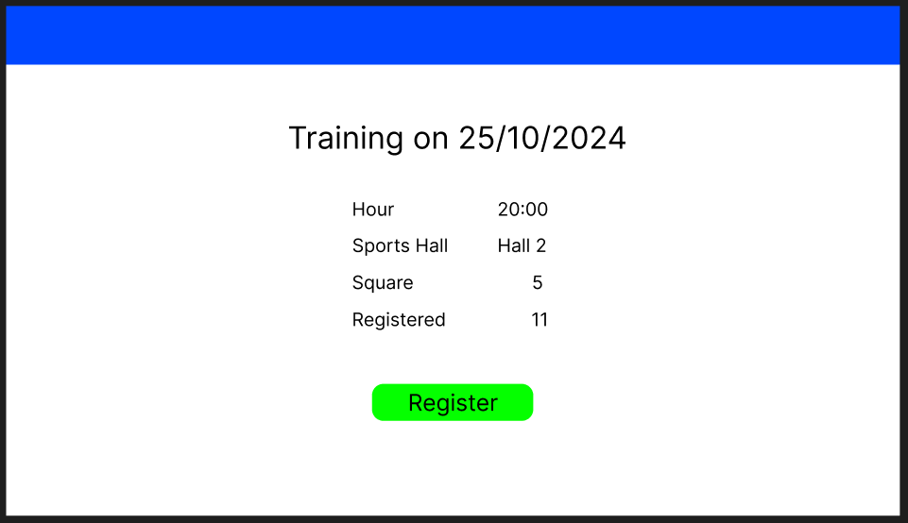

**Acceptance criteria:**

* If a player clicks on a button “register”, they are added to a training, their availability turns green, the number of attendants goes up by 1 and their personal attendants goes up by 1
* A player cannot be present at a training in the past
* A player can only register their own attendance

**User Story 4**

As a player

I’m able to register my absence on a training

So that I can keep my coach and teammates informed

**WireFrame:**

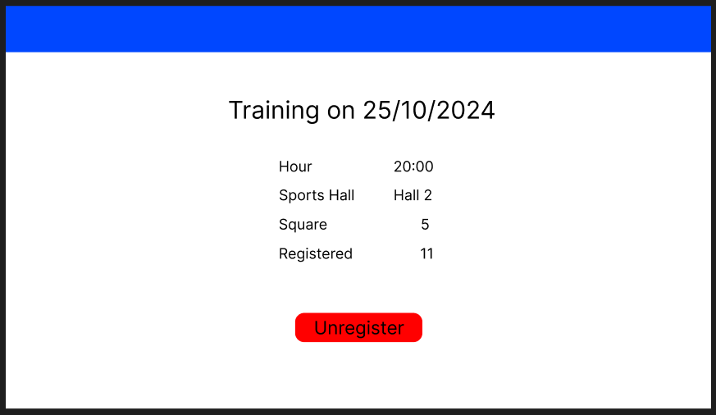

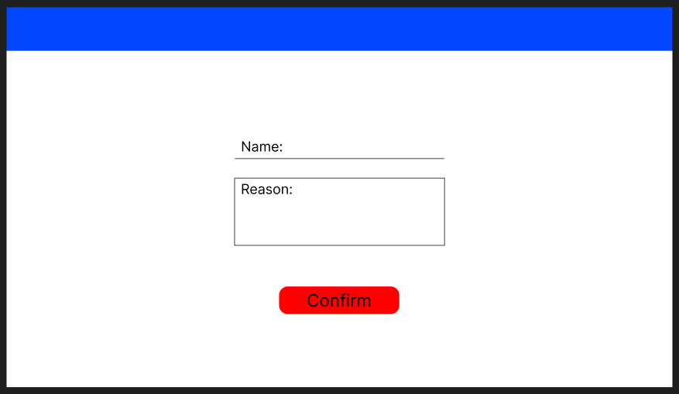

**Acceptance criteria:**

* If a player clicks on a button “unregister”, their availability turns red and attendance does not go up
* Only a player can register his own absence on a training

**User story 5**

As a player

I’m able to register my presence on a match

So that I can keep my coach and teammates informed

**WireFrame:**

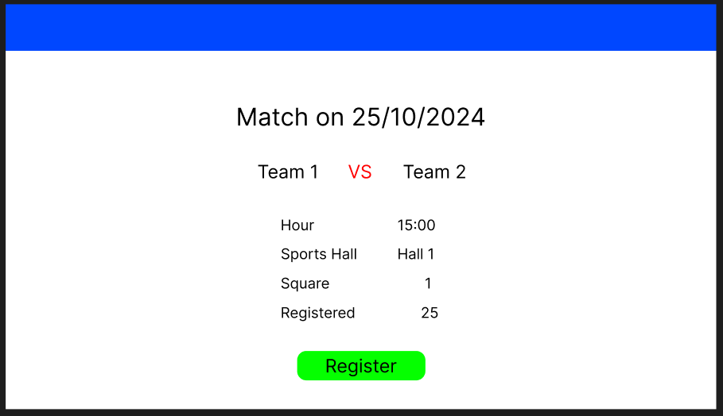

**Acceptance criteria:**

* If a player clicks on a button “register”, they are added to the match, their availability turns green, the number of attendants goes up by 1 and their personal attendants goes up by 1
* A player cannot be present at a game in the past
* A player can only register their own presence on a match

**User Story 6**

As a player

I’m able to register my absence on a game

So that I can keep my coach and teammates informed

**WireFrame:**

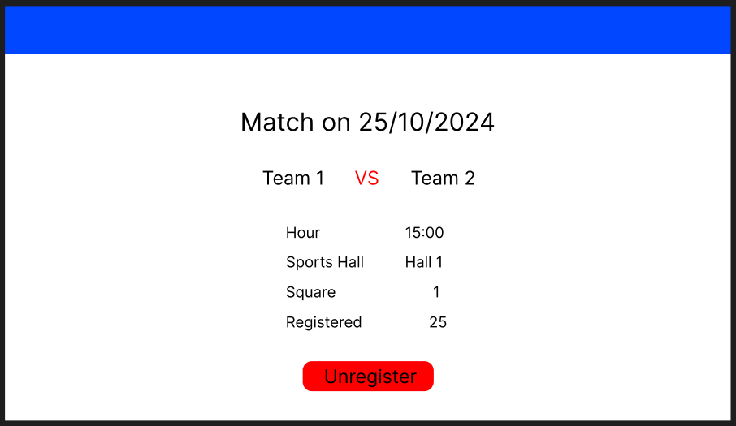

**Acceptance criteria:**

* If a player clicks on a button “unregister” their availability turns red and attendance does not go up
* A player can only register their own absence on a game

**User story 7**

As a coach

I’m able to see the attendance of all my players

So that I can see a short overview of the attendance of my team

**WireFrame:**

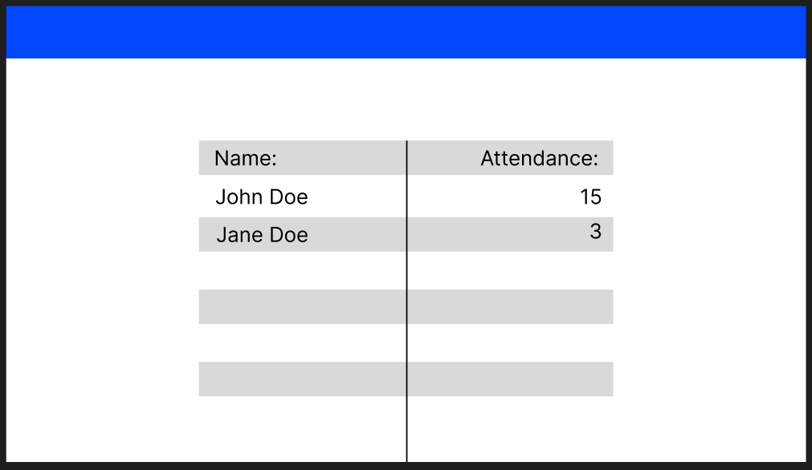

**Acceptance criteria:**

* Add an extra webpage with an overview of each players how many matches and trainings they attended (attendance/ total trainings and matches)
* Order them from most attended to less attended
* Everyone may see the statistics

**User story 8**

As an admin

I’m able to add a player to the team

So that I can manage and organize the team

**WireFrame:**

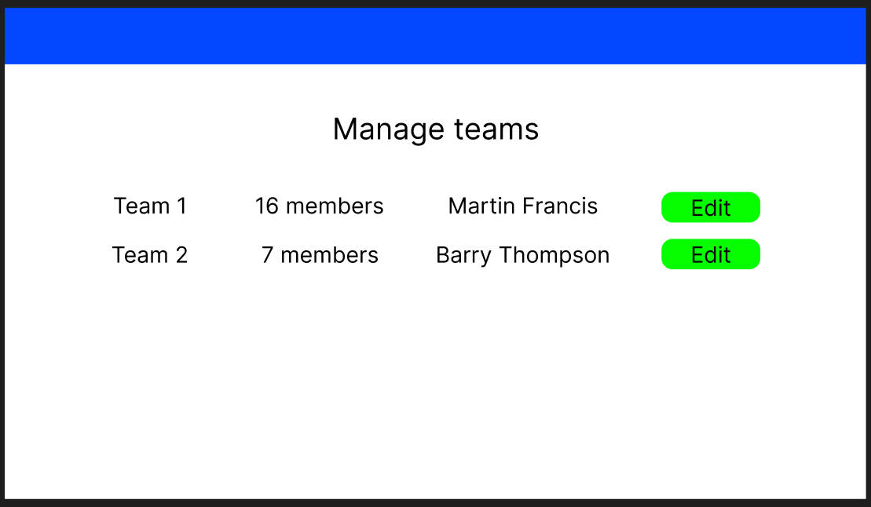

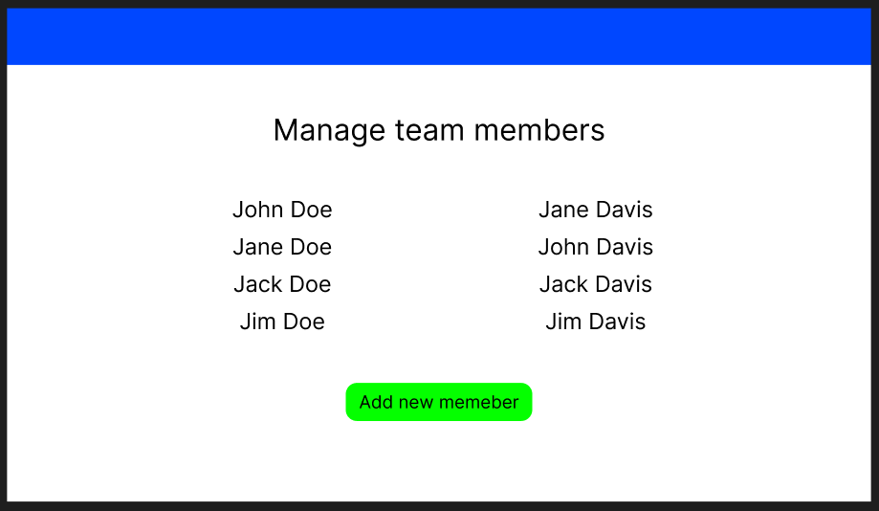

**Acceptance criteria:**

* An admin can add a player to the team in his own admin page with a button “add player”
* Only an admin can add a player
* The team list is updated

**User story 9**

As an admin

I’m able to remove a player from the team

So that I can manage and organize the team

**WireFrame:**

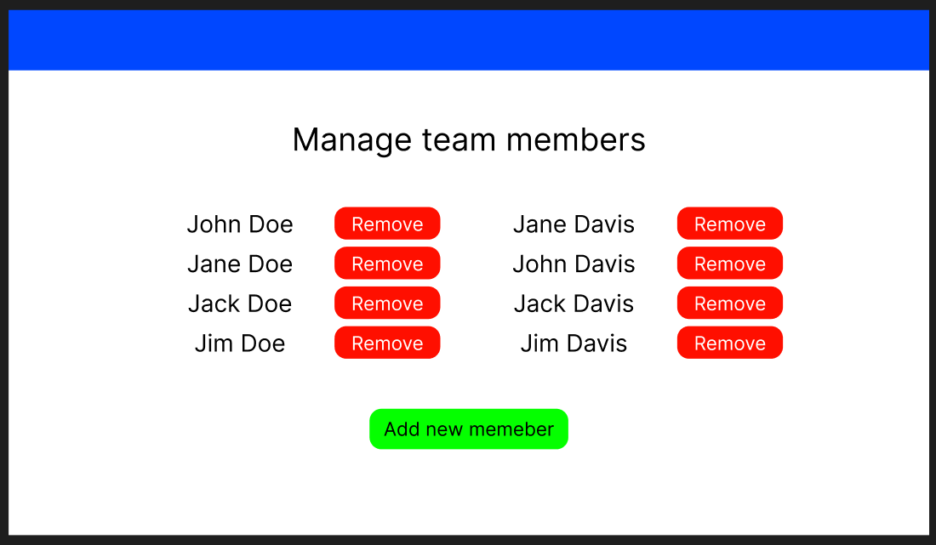

**Acceptance criteria:**

* On the admin page the admin can delete a player from the team
* Only the admin can delete a player
* The team list is updated

**User story 10**

As an admin

I’m able to add a coach to the team

So that I can manage and organize the team

**WireFrame:**

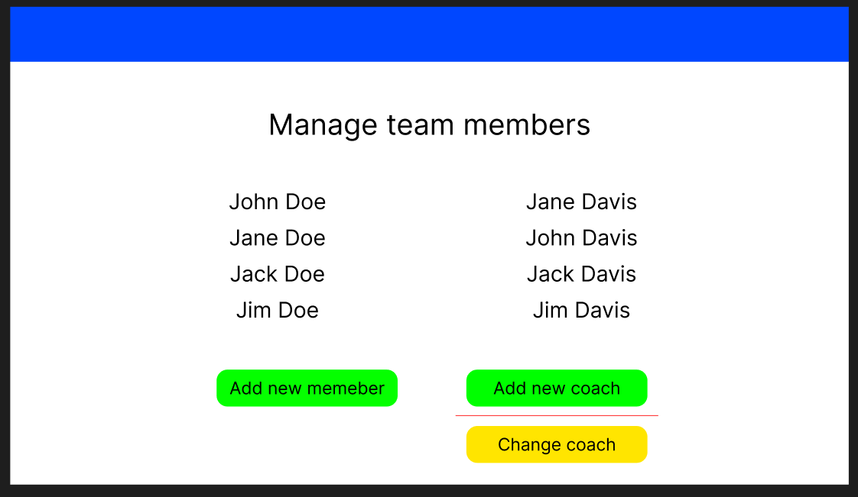

**Acceptance criteria:**

* An admin can add a coach to the team in his own admin page with a button “add coach”
* Only a admin can add a coach
* The team list is updated

**User story 11**

As an admin

I’m able to remove a coach from the team

So that I can manage and organize the team

**WireFrame:**

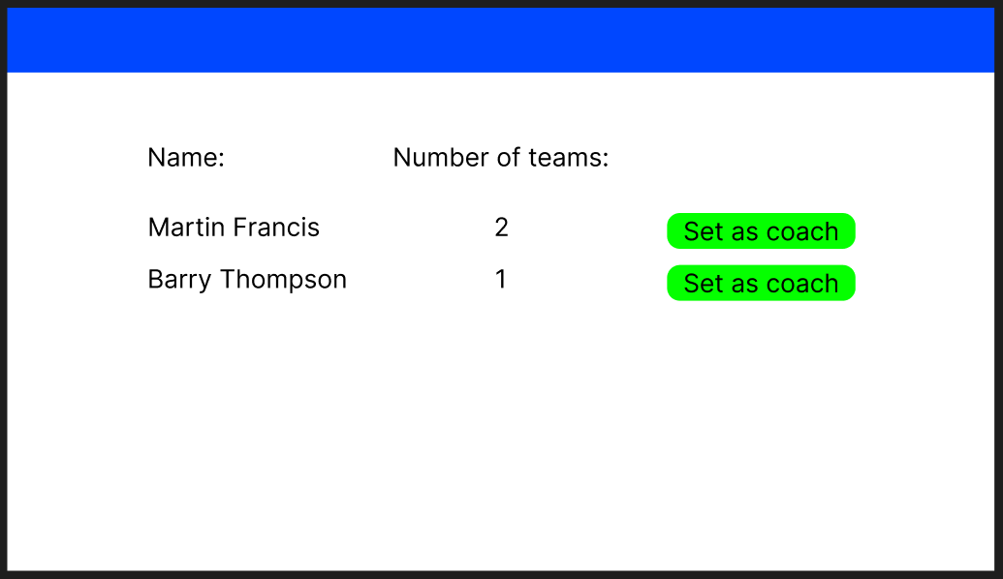

**Acceptance criteria:**

* On the admin page the admin can delete a coach from the team
* Only the admin can delete a coach
* The team list is updated